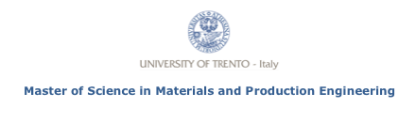

**Study of the evolution of microstructure and**

**thermo-mechanical properties in function of**

**sintering tempera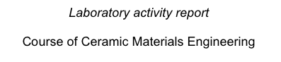ture for alumina–zirconia system**

Academic year 2018-19

**Federico Vespa**

Trento (Italy), 29 jan 2019